How to Effectively Communicate Your Message to Baby Boomers (Part One)
By: Anthony Herring
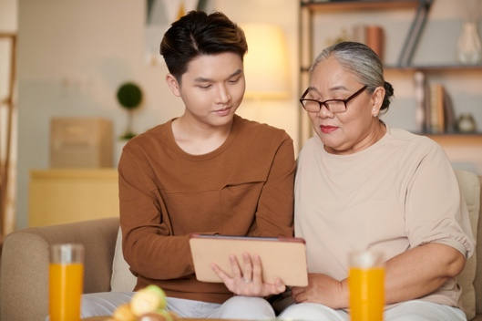
Introduction – The Task at Hand
Communication is a wonderful skill. It has allowed us to forge relationships, establish connections, and bond with our fellow humans on a personal and professional level. It takes care, diligence, and, ultimately, trust, to communicate effectively and honestly.
Unfortunately, it has its flaws. It can be used to harm and misinform. It can be weaponized for abhorrent purposes. It can be warped and misshapen, to the point where the intended message is unrecognizable to both those who received it and those who created it.
When considering these advantages and disadvantages, it’s of the utmost importance to fully understand the power of communication—especially as a member of the marketing industry. Communicating your brand message to consumers is a pivotal step in creating a relationship with them.
What ultimately makes the consumer base complex are the demographics, and since we work in senior living, our primary demos include baby boomers and members of the Silent Generation. While Silent Generation members make up a substantial portion of the retirement community population, baby boomers are the ones who will begin to think about staying in them. So, it’s key to understand how to properly communicate your branding to baby boomers so they’ll take your communities into consideration (and hopefully choose to stay in them).

1 – Who are the Baby Boomers?
Before we can discuss that, however, we must answer one important question: just who are the baby boomers?
According to the website Investopedia, the baby boomer generation was the cohort of children born in the eighteen-year period of 1946 to 1964. They are the successors of the Silent Generation (1928 – 1945) and the predecessors of Generation “Gen” X (1965 – 1980). They are given their name due to the eponymous “baby boom,” a result of the end of World War II. When the war ended, many were happy that a time of such destruction was finally over, so they celebrated by creating new families.
As of 2023, boomers are the second oldest living generation (the first being the Silent Generation, who would be in their eighties and nineties now). Thanks to this, boomers are either reaching or firmly in retirement age (as USA Today notes), making them the prime candidates for retirement communities!

2 – Boomers and Tech
Let’s just say that baby boomers and technology aren’t…the best of friends. Unlike their younger counterparts in Gens Z and Alpha—and even Millennials / Gen Y—boomers aren’t digitally literate. They have difficulty grasping the latest technological trends, often requiring help in attempting to use newer devices.
This isn’t surprising, as—like Jan Golden of the Huffington Post discusses—boomers grew up in a time in which smartphones, social media apps, and the Internet were nonexistent. Back in their heyday (the seventies and the eighties), phones, mail—or “snail mail” due to its delivery speed—and fax machines were the dominant forms of technology. (Sure, the Internet did come around during the eighties, but it was a much different beast compared to the juggernaut that it is now.) Their brains are hardwired to the analog days of old, and because of that, attempting to adapt to a more digitized world is a rather difficult challenge.
However, the challenge is not impossible. Boomers have shown that despite their conflict with digitization, they are willing to work alongside it (perhaps knowing that they’ll have to come to accept it eventually, as change is inevitable). As the software platform Xeven Solutions touches upon, boomers over the past several years are open to welcoming assistance with learning about new technologies. They understand it can be beneficial to them, despite how difficult the learning process can be.

Conclusion – To Be Continued
With that, Part One is concluded. We hope this article has helped to give you a better understanding of baby boomers and how their relationship with technology has changed over the years. Part Two will go into more detail regarding how to use this information to effectively communicate your brand messaging to them. Stay tuned!

The details present in this blog article were comprised of information gathered from the sources listed below. I want to give credit where credit is due.
References
Young woman helping senior man with payment on Internet using laptop · Free Stock Photo (pexels.com)
Assisted Living Statistics: Population & Facilities in 2022 | A Place for Mom
Baby Boomer: Definition, Age Range, Characteristics, and Impact (investopedia.com)
Baby boomers: Age range, years and the generation's impact on society (usatoday.com)
Why do baby boomers don’t understand technology? - XevenSolutions
The Real Reason Baby Boomers Hesitate with Technology | HuffPost Post 50

